Scoreboard
This section will provide details from the scoreboard tweaks enabled by BUG. Here is a screenshot of the options screen:

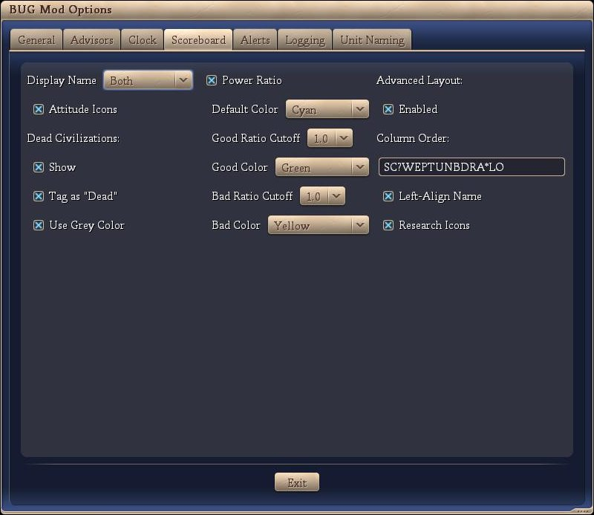

The balance of this section will detail each feature independently.

Display Name
There are three options under this combo:
Name: Displays the leader name on the scoreboard. This is the default behavior of civilization.
Civ: Displays the civilization name on the scoreboard.
Both: Displays leader name / civilization name on the scoreboard.

Attitude icons
This option displays an icon next to the display name showing the civ attitude towards the player. It’s the same as opening the Foreign Advisor screen or even hovering the mouse over the civilization name. The icons stand for:
Red Frowning Face: Furious
Annoyed:
Cautious:
Pleased:
Friendly:

Dead civilizations
This group of options adjusts how dead civilizations are displayed on the scoreboard. The options are:

Show
This is the default behavior of Vanilla and Warlords versions. BtS’ default is to hide the dead civilization. If you want to see who else was on the game and got killed, click this!

Tag as “Dead”
This option replaces the zero score with the text “Dead”.

Use Grey Color
This option greys out the dead civilization.

Power ratio
This option displays the power ratio between your civilization and the indicated civilization. It is a ratio of your power to their power. Numbers greater than 1 indicate that you are stronger than them. Naturally, this information is only displayed if you have enough espionage points to gather the required information. There are options to use colors as a visual aid. The color options are:
Default color: Default display
Good Ratio Cutoff: values greater than this number will be considered good.
Good Color: Display color for power ratios higher than the ‘good ratio cutoff’
Bad Ratio Cutoff: values shorter than this number will be considered bad
Bad Color: Display color for power ratios lower than the ‘bad ratio cutoff’

Advanced layout
The Advanced Layout option enables the user to modify the display order of items in the scoreboard. It also enables the user to remove items from the scoreboard.
The following table shows the keys available, some restrictions on their display (ie only for rivals) as well as differences between the BUG mod’s display and raw BtS.

Advanced Layout Item |  | Description |  | Restrictions |  | Differences to raw BtS
S |  | The civ's score |  |  |  | Nil
C |  | The civ's/leader's name |  |  |  | Column same width for all leaders. Left aligned if the ‘Left-Align Name’ option is checked
? |  | Shows a ‘?’ if you haven't met the civ of a human player yet in a multi-player game (PBEM, Hotseat, pitboss) |  | Multi-player only. |  | Nil
W |  | Current WAR status |  | Rivals Only |  | Fist displayed instead of ‘WAR’
E |  | Shows a spy icon if you have a positive espionage point ratio against the civ |  | Rivals Only |  | Nil
P |  | The civ's power ratio |  | Rivals Only |  | See above
T |  | The tech the civ is researching (vassals, teammates and espionage) |  | Rivals Only |  | Nil unless ‘Research Icons’ option is checked in which case the tech icon is shown
U |  | The number of research turns left (see T above) |  | Rivals Only |  | Nil
N |  | Shows the three-arrow icon when you are connected to the civ's trade network |  | Rivals Only |  | Nil
B |  | Shows a scroll icon when you have signed an open borders agreement with the civ |  | Rivals Only |  | Nil
D |  | Shows a similar scroll icon when you have signed a defensive pact with the civ |  | Rivals Only |  | Nil
R |  | The civ's state religion |  |  |  | Nil
A |  | The civ's attitude toward you |  | Rivals Only |  | See above
* |  | You are waiting for this civ to finish its turn |  | Online multi-player only |  | Nil
L |  | The civ's network stats (ping) |  | Online multi-player only |  | Nil
O |  | The network player is out-of-sync |  | Online multi-player only |  | Nil

Conclusion
Although a very heavy programming mod, the only additions to the raw BtS scoreboard display is the inclusion of attitude icons and the power rating.
Opinion: It is our opinion that no additional information is presented to the user via this section of the BUG mod and it should be approved.

